Chapter – 6: Reproduction in Animals

* Reproduction basic characteristic – living beings
* All organisms – simplest bacteria to complex humans – reproduce
* Reproduction – different methods –
  + Asexual –
    - Unicellular organisms, lower level animals – starfish, worms, etc
  + Sexual –
    - Multicellular organisms – dogs, cows, humans, etc

# Asexual Reproduction in Animals

* Single parent – produce offspring (new baby)
* Simplest form – without sex organs
* Bacterial cell – divides into daughter cells
* Also followed by plants – rose, potato, money plant, etc
* Amoeba – also use this method – produce 2 daughter cells
* Some common methods –
  + Budding –
    - Small bulb-like projection – bud – formed on parent body
    - After maturing (growing up) – bud detaches – grows into new individual
    - 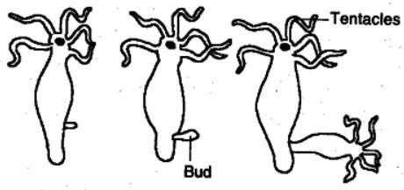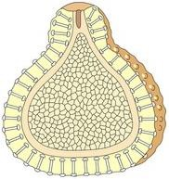Hydra, yeast – use this method
  + Gemmules (internal buds) –
    - This parent – produce specialized mass – develop into offspring
    - Sponges – use this method
  + Fragmentation –
    - Body of parent – breaks into different pieces
    - Each piece – grows into offspring
    - 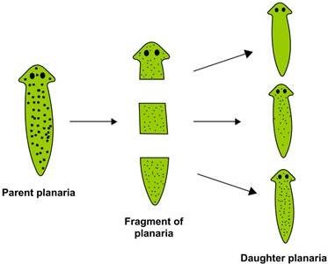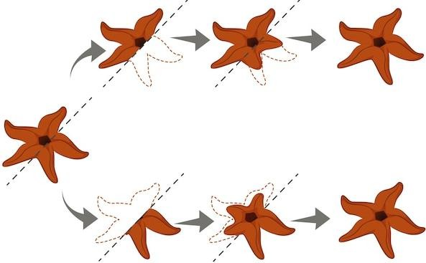Planaria, spirogyra – use this method
  + Regeneration –
    - Piece of parent’s body – detached – grows into new offspring
    - Starfish, lizard – show regeneration
  + Binary fission –
    - Simplest form – single cell organism – amoeba, bacteria – use this
    - Fully mature cell – splits into 2 cells
    - This division – starts with division of nucleus – then division of cell
    - 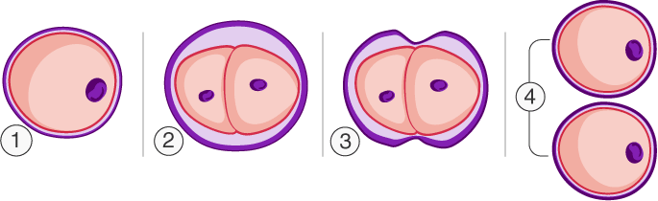2 new cells (daughter cells) formed – hence, binary fission

## Characteristics of asexual reproduction

* Offspring from single parent only – no variations
* New baby – exactly identical to parent

# Sexual Reproduction in Animals

* Requires 2 organisms – 1 male and 1 female
* Common example – human reproduction
* Male, female – special organs – produce gametes – this purpose
* Male gamete – sperm female gamete – ovum (egg)
* Union of these 2 – form zygote – forms into new organism
* This union process – sperm and ovum – fertilization
* 2 types of fertilization –
  + External –
    - Most common – aquatic animals – fish, frogs, etc
    - Eggs – released by females – into water – fertilised by males afterwards
    - Amphibians (live in water and land) – frogs, toads – goes into water – rainy season
    - Male and female – meet each other – female lays eggs (100s)
    - Eggs – covered with jelly-like structure – protection
    - Males – deposit sperms – directly over the eggs
    - Sperm – long tails – helps to swim
    - Fusion of gametes – outside the body – hence, external
    - Such animals – lay 100s of eggs – many eggs – may be eaten by other animals
    - Large number – increases probability of survival
    - After fertilization – embryo grows inside egg – after development – eggs hatch into young ones

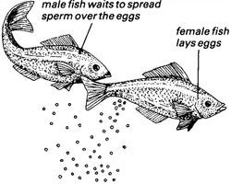

* + Internal –
    - Animals – birds, dogs, cows, goats, etc – fertilization – inside female body
    - Humans – also show this type of fertilisation

## Characteristics of sexual reproduction

* Zygote – result of fusion – male, female gametes
* Zygote – genes from both – father (male) and mother (female)
* Variations in characters of offspring

# Oviparous and Viviparous Animals

* Oviparous –
  + Egg-laying animals – lizards, frogs, fish, snakes, etc
  + Eggs – hatched by mother (body warmth) – OR – sun’s warmth – incubation
  + Birds – also lay eggs
  + Just after fertilization – zygote divide repeatedly
  + Zygote – travel down the oviduct – many protective layers form
  + Once – hard shell developed – bird lays eggs
  + After 3 weeks – embryo develops into young one
  + Young one – completely developed – they break the shell – come out – hatching
* Viviparous –
  + Give birth to young ones – directly
  + Rats, squirrels, buffaloes, humans, etc

## Metamorphosis

* Newborns or hatched young ones – grow until they become adults
* Newborn mammals (human baby) – hatched young ones (birds) – similar to their parents – shape, structure
* Some animals – butterflies, silkworms, frogs, etc – not the same
* These young ones – different in shape, structure
* They go through – various stages – life cycle – grow into adult
* Mosquito life cycle – egg → larva → pupa → adult
* 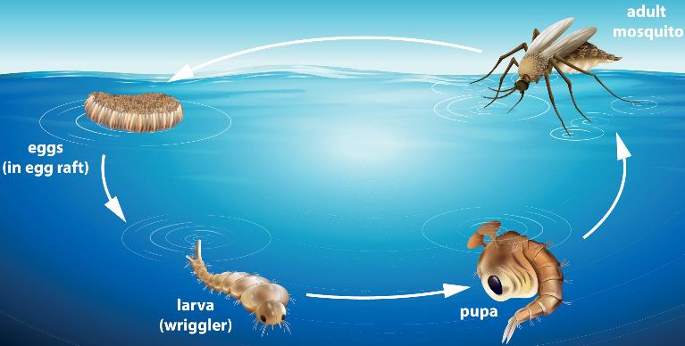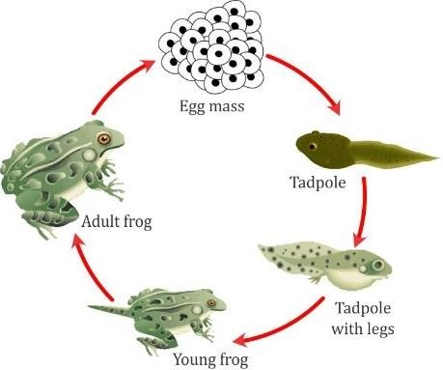Frog life cycle – egg → early tadpole → late tadpole → adult
* Both cases – intermediate stages – young ones – very different from adults
* Transformation – young one to adult – drastic (too much) changes - metamorphosis

# Reproduction in Humans

* Humans – reproduce – sexual reproduction – female (mother) – bears (carry) and give birth to child
* Reproductive systems – male, female – very different and specific
* Different steps – discussed below

## Male reproductive system

* Produce male gametes – sperms
* Sperms – elongated, small-size cells
* Each sperm – single cell – contain all cell components
* Components – head, middle piece, tail – swim with help of tail
* Following organs –
  + Testes –
    - Pair of testes – testis (singular)
    - Located – outside abdominal cavity – small pouches – scrotal sacs
    - Functions –
      * Produce millions of sperms (male gametes)
      * Produce male sex hormone – testosterone
  + Vasa deferentia (sperm ducts) –
    - Sperms – leave testes – pair of narrow ducts – vasa deferentia – deferens (singular)
    - Sperms – move through vas deferens – fluids from male glands – mix with sperm – new fluid – semen
    - These secretions – nourish the sperm – increase mobility (ability to move)
  + Urethra –
    - Vas deferens – open into urethra – narrow duct – coming from urinary bladder
    - Semen – poured into urethra – passed through centre – external male genital organ – penis
  + Penis –
    - Helps – transfer semen into vagina of female
    - 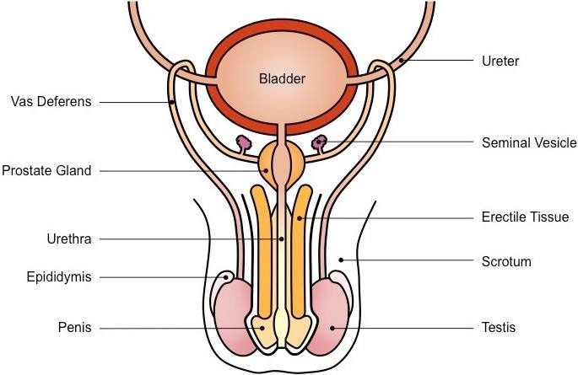Common passage – urine, semen – come out

## Female reproductive system

* 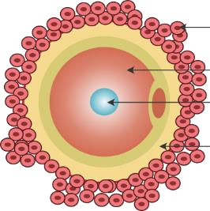Produce female gametes – eggs or ova – ovum (singular)
* Following organs –
  + Ovaries –
    - Pair – round-shaped ovaries
    - Located – lower abdominal cavity – female
    - Functions –
      * Produce female gamete – ovum – 1 ovum – released every month – ovum – round in shape – bigger than sperm – stores food – single cell – immobile – cannot move
      * Produce female sex hormones – oestrogen, progesterone
  + Fallopian tubes (oviducts) –
    - Ovum – after released by ovary – passes to oviduct
    - Sperm meet ovum – inside oviduct – fertilization takes place
  + Uterus (womb) –
    - Pear-shaped, thick-walled, muscular organ
    - Zygote – grows into baby – inside womb
    - Lower narrow part of uterus – cervix
  + Vagina –
    - 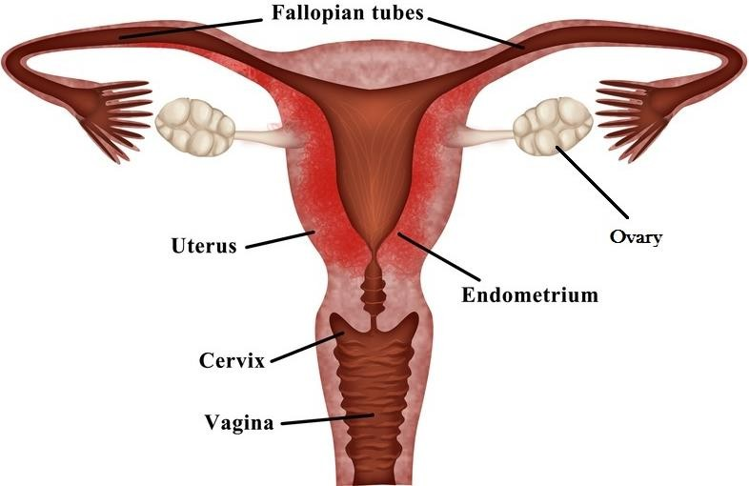Female genital organ – receives sperm from male

## Fertilization

* Inside oviduct of female – sperms meet ovum
* On sperm – may fuse with ovum – form single cell – zygote
* This process – fertilization
* 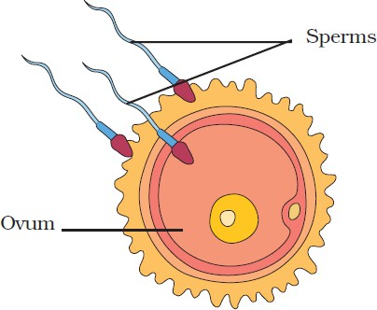Nucleus of ovum – fuse with – nucleus of sperm – form single nucleus

## Development of embryo

* After fertilization – zygote – moves down oviduct – divides repeatedly – form ball of cell
* This structure – embryo – gets embedded into the wall
* This process – implantation – embryo further developed here
* Embryo – slowly develop different body parts – hands, legs, head, eyes, ears etc
* Stage of embryo – all body parts – identified clearly – foetus
* Growing embryo – obtain nourishment (food) – mother’s body – through placenta, umbilical cord
* 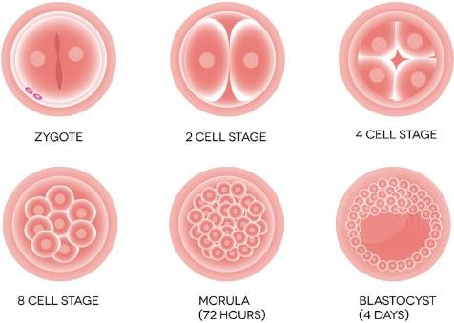When foetus – developed completely – mother gives birth

## Gestation

* Woman – having a baby inside womb – pregnant
* Period – fertilization to birth – gestation period
* This period – 40 weeks (9 months) - humans

## Childbirth

* Completion of gestation period – baby delivered
* Natural childbirth (labour) – several hours – may be painful for mother
* Sometimes – complications occur – may need surgical delivery – doctors take out child from womb
* This process – caesarian delivery
* Sometimes – babies born before completion of gestation period – premature babies – need special care

## What happens if fertilization does not occur?

* Before fertilization – uterus prepares itself to receive embryo
* Walls – supplied too much – blood vessels
* If ovum – not fertilised by sperm – blood vessels – rupture (break)
* Ovum – expelled (thrown out) from uterus – along with uterine muscles and blood
* This process – known as menstruation